Name: Talha Siddiqui

Threat Mitigations Suggestion for Thread Model:
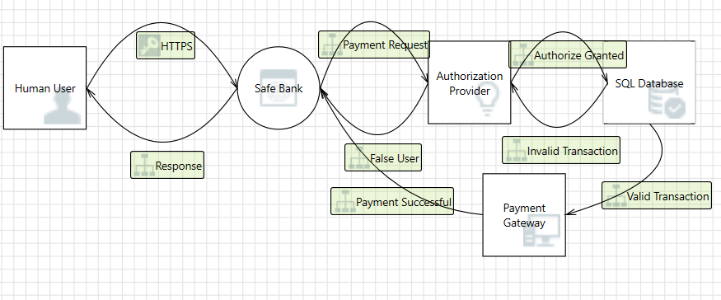

Threat 1: Elevation of Privileges on Payment Request.
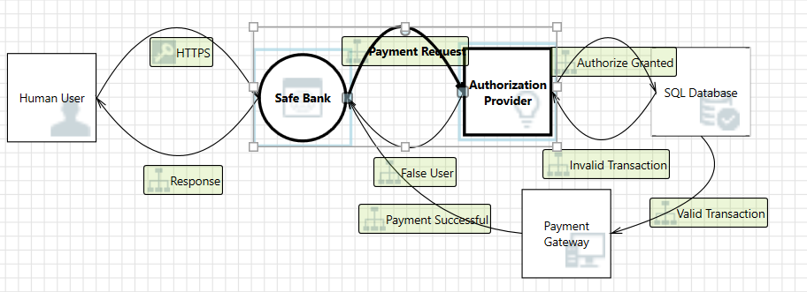

Threat 2: Information Disclosure on Valid Transaction.

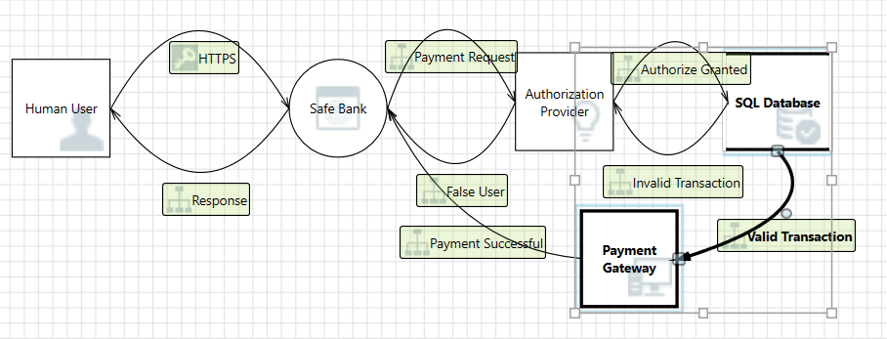

Threat 3: Spoofing Human User may be Spoofed by an attacker.
